# Project proposal for

# DST &Texas Instruments Inc.

# India Innovation Challenge Design Contest 2016

# Anchored by IIM Bangalore

# Wi-Fi Based Indoor Navigation System for the Visually Impaired

# SSN COLLEGE OF ENGINEERING

|  |  |  |  |  |
| --- | --- | --- | --- | --- |
| Name | College ID/Roll No. | UG/PG | Course/Branch | Semester |
| Vimalraj K | 312214106125 | B.E. | ECE | 05 |
| Somasundar S | 312214106104 | B.E. | ECE | 05 |
| Sivasankar P | 312214106102 | B.E. | ECE | 05 |
| Ravishankar R | 312214106085 | B.E. | ECE | 05 |
| Prakash V  Naveen Narayanan M | 312214106073  312214106066 | B.E.  B.E. | ECE  ECE | 05  05 |
| Faculty Mentor Dr. Rajavel R  Dr. Joseph Gladwin S |  |  |  |  |

<Team size can be from 2 to 5 student members>

# Project Abstract

Visually challenged people all over the world face difficulty in finding their way to an unknown location. They depend on others to guide them to their requisite place. This causes difficulties to people and consequently may lead to accidents. Hence, this project aims to develop a system using the current technology to enable indoor navigation for the visually challenged people.

Hence, the proposed system will provide vocal assistance to the visually challenged using a microcontroller/ Wi-Fi transceiver which is connected to the Wi-Fi system in the building.

Based on the location of the person a voice message is sent to the device which can be heard through a headphone and the visually challenged person can move about freely without any hassles and reach the particular location safely.

Keywords:

# Team Members – Roles & Responsibilities

|  |  |  |  |
| --- | --- | --- | --- |
| **S.No.** | **Student Member Name** | **Role (Choose one of the following – Marketing, Technical, Operations & Other Roles as applicable)** | **Justification** |
| 1 | Vimalraj K | Operations |  |
| 2 | Somasundar S | Technical |  |
| 3 | Sivasankar P | Operations |  |
| 4 | Ravishankar R | Marketing |  |
| 5 | Prakash V  Naveen Narayanan M | Technical |  |

# Market Analysis

Teams to provide a detailed study about the customer needs [in context of India] leading to identification of the problem being solved which coversthe Total Addressable Market (TAM), Serviceable Addressable Market (SAM), study of existing solutions [Competition]and opportunities for enhancing/improving the solution leading to the proposed solution.

Teams to validate their analysis with usinggraphs, illustrations and quantitative data from different sources as applicable.

1. Customer Need Identification - <Teams to present thier case & Share information>
2. Serviceable Addressable Market (SAM) Identification & Justification - <Teams to share details of their SAM and support with analysis as applicable>
3. Product Differentiation w.r.t. Competition& Justification - <Teams to Highlight the differentiated featues of their product w.r.t. to completion/existing product with justification>
4. Understanding of your customer & user- <Teams to identify their customer & user and share their product positioning to enable ease of adoption for both of these >

***Note:*** Users refer to people using the product/service, and a customer is one who pays for the product/services***. Depending on product both could be same or different.***

1. Distribution Channel Identification - <Teams to share how would you deliver the product/service to the customers/users>

# Proposed Design

A. Objective: The objectives of this project are to;

1. Setup a server that has the different audio files with directions

2. Place Wi-Fi routers at different points and connect them to the server through a common switch.

3. Design a standalone system using a microcontroller with 3.5mm audio jack.

B. Proposed Solution

* 1. Block Diagram – \

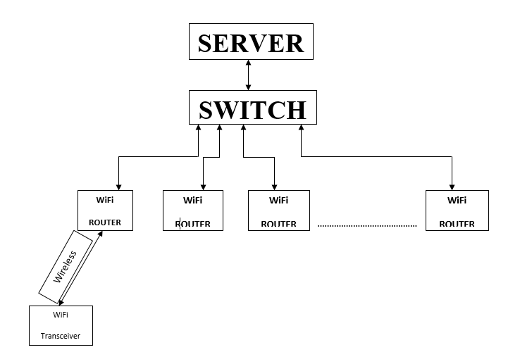

1. Component Used -

|  |  |
| --- | --- |
| TI Part Number  (link all the parts to their respective product page on the TI website) | How is it being used in the proposed solution? Explain its role/functionality |
| Part 1- TDC 100 | Used to detect the nearby obstacles |
| Part 2-CC300 | Microcontroller with Wi-Fi module |
| Part 3 |  |
| Part 4 |  |
| Part 5 |  |

|  |  |
| --- | --- |
| Non - TI Parts | How is it being used in the proposed solution? Explain its role/functionality |
| Part 1 | Wireless Router |
| Part 2 | A PC which acts as a local server |
| Part 3 |  |
| Part 4 |  |
| Part 5 |  |

# Innovativeness of the Proposed Solution

Teams have to explain the uniqueness/differentiation of their proposed solution with respect to the existing competition in the current scenario. Teams can differentiate their proposed solution on the following vectors – size, power, performance, cost, functionality& others as applicable

# Impact of the proposed solution

After successful completion of the project, the developed

smart standalone SLT system would help the visually challenged persons for indoor navigation without any hassles and reach the particular location safely by providing

vocal assistance. This system could be implemented in different Malls, Hospitals, Railway Stations, Schools, and Colleges etc.

Images of the Proposed Model.

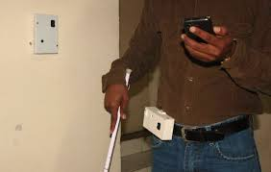

# Feasibility

Teams have to explain the practicality of the idea to be converted into a product in current market scenario in India. Teams can share their brief plan for manufacturing the product in India. Teams can refer to generic product development lifecycle to form their plans.